`Pac-Poly-Marquesas Fish hook-Ceremonial

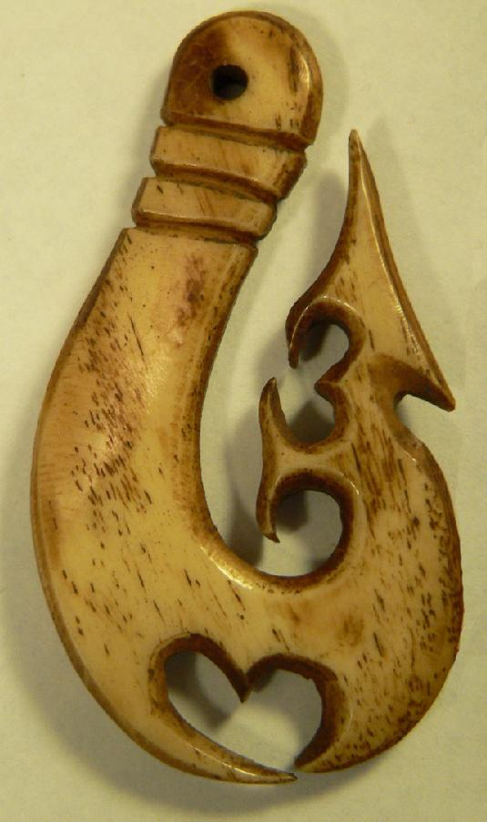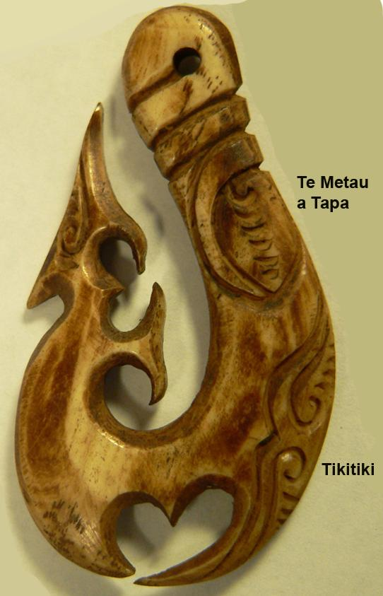

Fig. 1, right side; Fig. 2, engraved left side.

Ceremonial bone fish hook from **Atuona**, located on Atuona Bay on the southern side of Hiva Oa island, Marquesas Islands. This fish hook of the hero Maui, with which he fished the island Tona'eva, is in the same tradition as the one procured by Karl von den Steinen for the Berliner Museum für Volkerkunde at **Atuona** in 1897, which was lost or destroyed in World War II (Blau, Maaz, Meyer, Picasso 2012: 212-213). von den Steinen recorded a myth about such ceremonial fish hooks : "It was used as a sacrificial hook in the world of the living, placed into the mouths of the human sacrifices, when the bodies were hung from a tree on the *Marae*, to designate the victims as the fish of the gods. According to another visually interpreted account, one speaks of the 'hook of tapa,' *Te Metau a Tapa*, the horrible old woman of the heavens, the cannibal, who cast her fishing line down to earth, to catch and haul up victims for her cooking pit" (von den Steinen 1928: 110-111). In Fig. 2 above she is the Tiki at top right to whom the Maui Tikitiki (figure below) belongs.

References:

Blau, Daniel, Maaz, Klaus, Meyer, Anthony J. P., Picasso, Sydney. 2012. *Fish hooks of the Pacific Islands : a pictorial guide to the fish hooks from the peoples of the Pacific Islands*. Munich ; London : Daniel Blau ; Munich : Hirmer.

von den Steinen, Karl. 1928. *Die Marquesaner und ihre Kunst : Studien über die Entwicklung primitiver Südseeornamentik nach eigenen Reiseergebnissen und dem Material der Museen / Bd. 2, Plastik : mit einer Einleitung über die "materielle Kultur" und einem Anhang "Ethnographische Ergänzungen."* Berlin: Dietrich Reimer; Ernst Vohsen.

|  |  |
| --- | --- |
| Order details |  |
|  |  |
| Payment details |  |
|  |  |

|  |
| --- |
| Shipping details |
| **Ralph J Coffman Jr**  149 Atlantic Ave  Swampscott MA 01907-2427  United States |

## Order details

|  |  |  |  |
| --- | --- | --- | --- |
| **Item title** | **Available actions** | **Shipping & handling (estimated delivery*)** | **Price** |

[Printer version](http://payments.ebay.com/ws/eBayISAPI.dll?ViewPaymentStatus&transid=1166401316015&userloginid=802-867&printerversion=true&itemid=251213744983)

|  |  |  |
| --- | --- | --- |
| Seller: | [**Member id** pickitsellit](http://myworld.ebay.com/pickitsellit) ( [**Feedback Score Of** 13](http://feedback.ebay.com/ws/eBayISAPI.dll?ViewFeedback&userid=pickitsellit)) | [Contact seller](http://contact.ebay.com/ws/eBayISAPI.dll?ShowCoreAskSellerQuestion&frm=3998&iid=251213744983&redirect=0&requested=pickitsellit) |

|  |  |  |  |  |
| --- | --- | --- | --- | --- |
| Paid on Jan-18-13 via PayPal | | | | |
|  |  |  |  |  |

|  |  |  |  |  |  |  |  |  |
| --- | --- | --- | --- | --- | --- | --- | --- | --- |
|  | [**Item Title:**Old Bone Fish Hook Beautiful Engravings Bone Artifact Patination Drilled Hole**- opens in a new window or tab**](http://cgi.ebay.com/ws/eBayISAPI.dll?ViewItem&item=251213744983)  **Item Id:**251213744983 - Price: US $34.00  Quantity:1  Having a problem with this purchase? [We can help](javascript:;) | |  | | --- | |  | | |  |  | | --- | --- | | [Leave feedback](http://feedback.ebay.com/ws/eBayISAPI.dll?LeaveFeedbackShow&useridfrom=802-867&useridto=pickitsellit&item=251213744983&transactid=1166401316015) |  | | | Economy Shipping: **FREE**  Estimated delivery: January 23 - February 5 | US $34.00 |



|  |  |  |  |  |
| --- | --- | --- | --- | --- |
|  | |  | | |
|  | |  | | --- | |  | | [AdChoice **- opens in a new window or tab**](javascript:void(0);) | | | |  |  |  |  |  |  |  |  |  |  |  |  |  |  |  |  |  |  |  |  | | --- | --- | --- | --- | --- | --- | --- | --- | --- | --- | --- | --- | --- | --- | --- | --- | --- | --- | --- | --- | | |  | | --- | | |  |  |  |  |  |  |  |  |  |  |  |  |  |  |  |  |  | | --- | --- | --- | --- | --- | --- | --- | --- | --- | --- | --- | --- | --- | --- | --- | --- | --- | | |  |  | | --- | --- | | Subtotal: | US $34.00 | |  | | | Shipping & handling: | FREE | |  | | |  | | |  | | | Total: | US $34.00 | |  | | | | | |  |